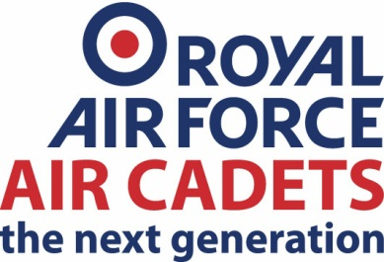
1330 (Warrington) Squadron
Air Training Corps
Tedder House
Peninsula Barracks
O’Leary Street
WARRINGTON
WA2 7QS

Tel: 01925 555130
Email: oc.1330@rafac.mod.gov.uk

Dear Parents/ Guardians,

The monthly subscription fee for membership to 1330 (Warrington) Squadron Air Training Corps is £17.50. You are reminded that subs are paid regardless of attendance until you have officially left i.e. handed in uniform and paid off monies owing etc.

Your son / daughter will start paying subs from: _________________________________*
*1st of the month plus 1 MONTH
All the money collected is used to provide equipment and subsidise attendance at external events etc.

For ease of payment subscriptions are collected by standing order. The squadron information is as follows:
BANK: |  | TSB
BRANCH: |  | WARRINGTON
SORT CODE: |  | 77 - 79 – 03
ACCOUNT: |  | 02720368
NAME: |  | 1330 Warrington Squadron ATC
REFERENCE: |  | CADET SURNAME:  Please add your unique reference
Please use the information to raise a standing order on an internet banking service. Complete the tear-off slip at the bottom and return to the Squadron. We suggest you use the son / daughter’s surname for reference and payment on the 1st of the month. If you are unable to pay using this method, please discuss this matter with a member of staff.

Yours faithfully,

Flight Lieutenant Alan Radcliffe
Officer Commanding
1330 (Warrington) Squadron

DETACH AND RETURN BELOW DOTTED LINE
- - - - - - - - - - - - - - - - -- - - - - -- - - - - - - -- - - - - - - - - - - - - - - - - - - - - -- - - - - - - - - - - - - - - - - - - -

CADET SUBSCRIPTIONS BY STANDING ORDER

NAME OF CADET(S): __________________________

I will be paying my son/daughter’s* subscriptions by standing order from _____________( dd-mm-yy)

The reference name for the standing order payment will be: _______________________________
(Must match the name on the mandate)

SIGNED: _________________________ PRINT NAME: _________________________

