INITIAL KITTING - UNIFORM SIZE REQUIREMENTS

SURNAME: __________________ INITS: ______

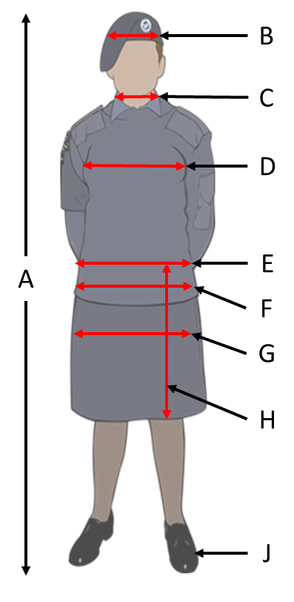 | 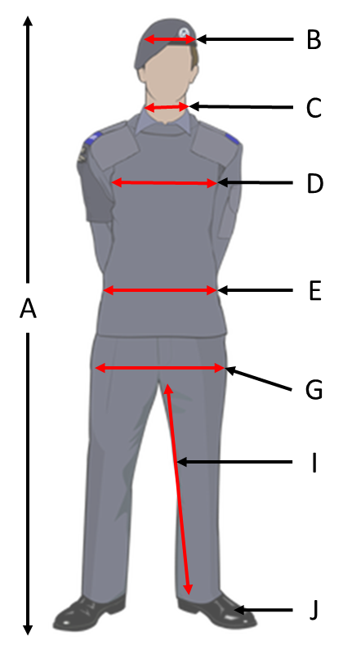

Key | Measurement | Value  (cm) | Description
A | HEIGHT |  | Head to toe height without shoes.
B | HEAD |  | Measure horizontally around the head, approximately 2.5cm above the eyebrow
C | NECK |  | Measure horizontally around the fullest part of the neck
D | CHEST |  | Measure around the fullest part of the chest
E | WAIST |  | Measure around the waist.
F | HIPS |  | Measure around the fullest part of the hips (female cadets only)
G | SEAT |  | Measure around the fullest part of the bottom.
H | WAIST TO KNEE |  | For skirt length (female cadets only)
I | INSIDE LEG |  | Measure from the top of the inside of the leg to the ankle.
J | HOODY SIZE |  | Standard Hoody Size S/M/L the hoodies can be adult sizes

COMPLETE & RETURN WITH UNIFORM DEPOSIT AS SOON AS POSSIBLE.

